23rd September 2026

Internship Project Certificate

This is to certify that Mr. Kishore Kumar L (Reg.No:44734015), M.Sc., (Computer Science) student of Sathyabama University, Chennai has successfully completed the project titled “A Potent Argument Rentention Report in an Archetype Director" at Gradtwin Services, from June 2026 to August 2026 in the Full Stack Developer - Java Domain.
We have found his contributions to the project were valuable, and he demonstrated a high level of dedication, skill, and professionalism throughout his time with us.
We are proud to have had Mr. Kishore Kumar L as part of our team and wish him continued success in his future endeavours. We wish him the best for his future.

For Gradtwin Services (OPC) Private Limited
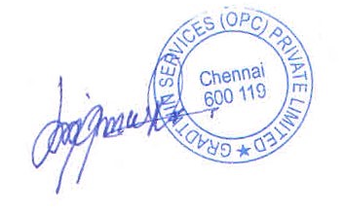
Kanishrajiah Durairaju
Manager - Human Resource

